BACHELOR OF COMPUTER SCIENCE

SCHOOL OF COMPUTER SCIENCE
BINA NUSANTARA UNIVERSITY
JAKARTA

ASSESSMENT FORM
Course: COMP6791051 - Program Design Methods
Method of Assessment: Case Study and Project
Semester/Academic Year : 1/2023-2024

Name of Lecturer : Dimas Elang Setyoko
Date : 12-21-2023
Class : LB-95
Topic : Input-Process-Output, Analysis Modeling, Business Process and Functional Modeling

Group Members : | 1 LIAUW, JEREMY MARVELLE  2 GREGORIUS DARRELL ANDIKA SETYA  3 JOSHUA NATHANAEL BUDICHANDRA  4 JOVIAL MISAEL

Student Outcomes:
SO 2 - Mampu merancang, mengimplementasikan, dan mengevaluasi solusi berbasis komputasi untuk memenuhi serangkaian persyaratan komputasi dalam konteks ilmu computer
Able to design, implement, and evaluate a computing-based solution to meet a given set of computing requirements in the context of computer science.
SO 6 - Mampu untuk menerapkan teori ilmu komputer dan dasar-dasar pengembangan perangkat lunak untuk menghasilkan solusi berbasis komputasi.
Able to apply computer science theory and software development fundamentals to produce computing-based solutions

Learning Objectives:
(LObj 2.1) Mampu merancang solusi berbasis komputasi untuk memenuhi serangkaian persyaratan komputasi tertentu dalam konteks ilmu komputer
Able to design a computing-based solution to meet a given set of computing requirements in the context of computer science.

(LObj 6.1) Mampu menerapkan teori ilmu komputer yang digunakan untuk menghasilkan solusi berbasis komputasi
Able to apply computer science theory used to produce computing-based solutions

(LObj 6.2) Mampu menerapkan dasar-dasar pengembangan perangkat lunak untuk menghasilkan solusi berbasis komputasi
Able to apply software development fundamentals to produce computing-based solutions

Learning Outcomes:
LO 1: Explain the requirements of writing a program or system
LO 2: Apply pseudo-code to solve problem
LO 3: Analyze the requirements of a system
LO 4: Solve system design problems using UML

No | Related LO-LOBJ-SO | Assessment criteria | Weight | Excellent (85 - 100) | Good (75-84) | Average (65-74) | Poor (0 - 64) | Score | (Score x Weight)
1 | LO 1  LO 2  LObj 2.1  SO 2 | Ability to identify requirements for programs | 25% | Able to identify the input, process, and output of a program completely and correctly | Able to identify the input, process, and output of a program in less-completely and less-correctly | Able to identify the input, process, and output of a program in half-completely and half-correctly | Identify the input, process, and output of a program incompletely and incorrectly
2 | LO 2  LObj 6.1  SO 6 | Ability to apply pseudocode | 25% | The pseudocode written solves at least 90% of the programming problem | The pseudocode written solves at least 75% of the programming problem | The pseudocode written solves at least 60% of the programming problem | The pseudocode written solves less than 60% of the programming problem
2 | LO 3  LObj 6.1  SO 6 | Ability to collect the requirements for a system | 25% | All the necessary requirement of a system is collected | Some of the requirement of a system is collected | A few of the requirement of a system is collected | The requirement of a system is not collected
4 | LO 4  LObj 6.2  SO 6 | Ability to design a system using UML | 25% | Able to design at least 90% correct using UML | Able to design at least 75% correct using UML | Able to design at least 60% correct using UML | Able to design less than 60% correct using UML
 |  | Total Score: ∑(Score x Weight)

Remarks:

ASSESSMENT METHOD

Instructions:
- This project requires a group of three to four students to work together.
- After receiving a case study, students must:
  - Identify program requirements using IPO charts.
  - Develop the algorithm using pseudocode.
- Perform an interview or observation with a Binusian individual on the campus premises in order to gain insights into their daily responsibilities within the system unit in which they are positioned. Then:
  - Gather the functional and non-functional requirements of the system.
  - Draw a UML diagram(s) to describe the process.
- The assignment is compiled and presented in a singular .pdf format, subsequently being submitted through the binusmaya.

Note for Lecturers:

- It is advisable to inform the students to establish a group during the initial meeting in order to promptly commence their collaborative efforts on the assignment.
- In order to facilitate the submission of reports, lecturers have the ability to establish groups within the binusmaya platform.
- The submission of the report, ideally one week prior to the final exam, is to be carried out by a single student who will act as the representative for each group.

QUESTIONS
- Case Study (50%)

Since the COVID-19 pandemic, Binus University has implemented health protocols in its campus environment. One of them is by monitoring the body temperature of visitors before entering the campus building. In this process, security staffs monitor body temperature sensors at every building entrance. If the visitor's body temperature is less than or equal to 37.1 degrees Celsius then the visitor has a normal body temperature, so they are welcome to enter the building. However, if a visitor is indicated to have Covid, namely with a body temperature exceeding 37.1 degrees Celsius, the security staff will carry out a quarantine protocol by conducting an on-site antigen test. At the end of the day, the data record of body temperature for each visitor will be stored in a file called Todaysvisitors.dat.

As a developer, you are asked to create a pseudocode for an algorithm that calculates the total number for visitors with a normal body temperature and a body temperature suspected for Covid. The total number of visitors can be calculated based on the data record from Todaysvisitors.dat file as shown in the following Table 1.

Briella | 36.9
Ivory | 37.3
Nadia | 36.9
Uriel | 37.1
Sebastian | 36.8
Ivan | 37.2
Abigail | 37.0
Nathanael | 37.1
Thalia | 36.9
Wynter | 36.8
Eric | 37.3
Nina | 36.9
Tiffany | 37.2
Yara | 36.9
Samuel | 37.2
Ingrid | 36.9
Xavier | 37.0

Table 1: Todaysvisitors.dat file containing visitors’ name and their body temperature.

Your tasks are:
- [LO1, 25 poin] Define the requirements of the program with the IPO Chart. You may refer to IPO Chart definition in Tony Gaddis. (2019). Starting Out with Programming Logic and Design. 5th Edition. Chapter 2.2 Output, Input, and Variables.

- [LO2, 25 poin] Write a pseudocode for a program that can calculate the total number of visitors based on body temperature using the Todaysvisitors.dat file. The pseudocode should display the following output:

Today's Visitor Count by Body Temperature:

Normal Body Temperature: __
Body temperature suspected for covid: __
Total visitors: __

- Project (50%)

- [LO3, 25 poin] Conduct an interview or an observation on any Binusian (e.g., students, lecturer, staff/employee) to learn more about their daily tasks and the process it takes to complete the tasks. You may ask about what they do and analyze how they collaborate with others in the system where they are positioned.

As a group of programmers, you are interested in developing an application that automates their tasks and processes. Before developing the application, you are required to gather the requirements that the application may need. Define five functional and two non-functional requirements of the system for the application.

- [LO4, 25 poin] Identify the actor(s), scenario(s), and use cases (processes) and draw a use case diagram that describes the requirements specified in Question 2.a. If you use either <<extend>> or <<include>>, please provide a detailed explanation(s) about the reason. As a guidance in creating a use case diagram, you may refer to Alan Dennis, Barbara Haley Wixom, David Tegarden. (2015). Systems Analysis and Design An Object Oriented Approach with UML. 5th Edition. Chapter 4 Business Process and Functional Modeling. Page 126-127.

ANSWER :
- A.
Module main
Declare input FILE "Todaysvisitors.dat"
Open FILE "Todaysvisitors.dat"
Declare string nama
Declare integer nonSuspect, suspect
Set Total = 0
Set nonSuspect = 0
Set suspect = 0
Declare float temperature

While NOT eof(Todayvisitors.dat)
Read Todayvisitors.dat "nama"
Read Todayvisitors.dat "temperature"

Set Total = suspect + nonSuspect
If(temperature <= 37.1) then
Set suspect = suspect + 1

Else Set nonSuspect = nonSuspect + 1

End if
Display "Today's Visitor Count by Body Temperature: "
Diplay "Normal Body Temperature: ", nonSuspect
Display "Body temperature suspected for covid: ", suspect
Display "Total visitors: ", Total
Close file
End module

B.
Input | Process | Output
1. Visitor’s data from Todaysvisitors.dat  2. The maximum temperature for the visitor’s body temperature to be considered normal (37.1). | Loop through each visitor’s data and check if their body temperature is more than 37.1 and keep track of the count.  Visitor that’s suspected for Covid = The count  Visitor’s with normal body temperature = Total visitors - The count | Two integers that contain the data of how many visitors have normal body temperature and how many visitors that’s suspected for covid.

- A.
NON FUNCTIONAL
1. Operational Requirements
1.1 The app can be run on all device (Android, IOS, Windows, MAC, etc).
1.2. The system should be able to update into the database anytime and anywhere as long as it is connected to the internet.
1.3 The system should automatically back up at the end of each day.
1.4 The system have a discover for user daily activities.
2. Performance Requirements
2.1 The system should be able respond the input of the user, after the election in discover.
2.2 The time that is on the system is the same according to the user's choice of language.
2.3 The timr can be set according to user preference.
2.4 The system should be able to give users notification or alarm for remind the things to do.
3. Security Requirements
3.1 The system should validate the account, so that user data is safe.
3.2 The system should validate the account, ensuring unknown user can't access the primary user.
3.3 Secure encryption will be implemented to protect sensitive user data during transmission and storage.

-Function Requirement:
--Sign up
+For new user make account with Email / platform (Google, Facebook, Gmail).
--Login
+Email / platform (Google, Facebook, Gmail).
--Username
+after sign up/login users make username
--Profile picture.
+users can choose profile picture from gallery or take photo with camera.

-Function Requirement:
--Discover
+The display for options like alarm, things to do, workout, notes
-Alarm
+Can be set many times, The time on the alarm follows the time set in the language settings for example (Indonesian, Jakarta GMT 7).
-Things to do
+ Display the things that should do, This system runs according to the specified day and time.
-Workout
+Displays workout options to users and users can choose the workout model they want.
--Notes
+Users note

Function Requirement:
--Program Savings Balance
+To calculate income and outcome of users, so users can save their money.

Function Requirement:
--Program calculate calories
+Users can enter calorie calculations into this program, This program helps maintain body weight while exercising.

Function Requirement:
--Settings
+In setting system include language settings, account settings, and setting sound of notification or alarm.
-Language settings
+Language settings include 10 internasional languages.
-Account settings
+users can link account to another platform for security.
-Setting sound
+users can use sound from device or can use default sound for notification.

B.

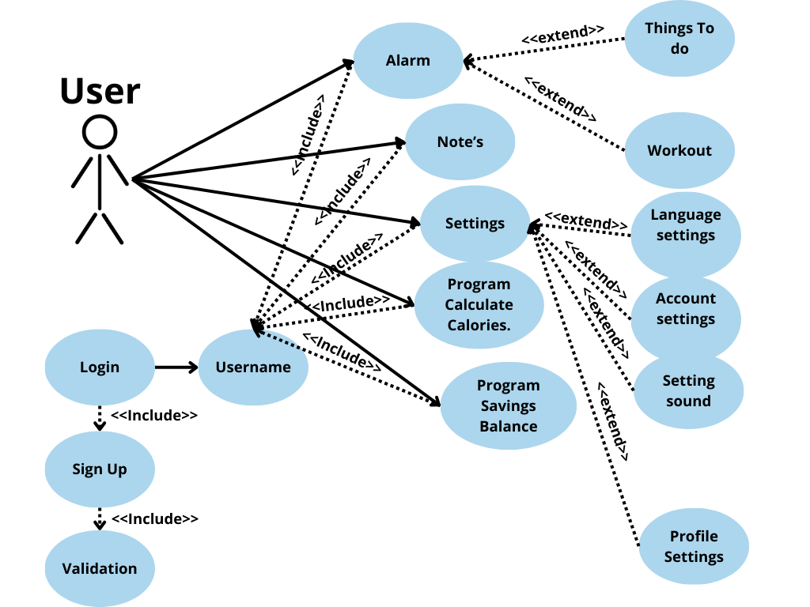

-- Good luck --

